SIMATS ENGINEERING (SAVEETHA SCHOOL OF ENGINEERING)
Department of Computer Science and Engineering
CO4 ASSESSMENT TOOL 2 – CI/CD Pipeline Design Exercise

Course Code: | CSA10 | Course Title: | Software Engineering
CO Assessed: | CO4 | Assessment: | Assessment Tool 2 – CI/CD Pipeline Design Exercise
Weightage: | 20% | Total Marks: | 25
CO4 Statement: | Implement robust testing, quality assurance, and DevOps practices, emphasizing security, reliability, and ethics
Student Name: | Surya Krishna Teja Yandra | Reg. No.: | 192425065
Date: | 18-08-2026 | Duration: | 60 minutes

Code of Conduct
I Surya Krishna Teja Yandra/192425065 (Name / Reg No) certify that this submission is my original work and that I have adhered to the guidelines specified for this assessment. I understand that any violation of academic integrity rules will result in disciplinary action.
Signature of the Student: _________________________
Annexure A – CI/CD Pipeline Design Exercise
Instructions to Students:
Each student is assigned an individual problem statement. Based on the assigned problem statement, design a CI/CD (Continuous Integration and Continuous Deployment) pipeline for the proposed software system to automate the processes of code integration, building, testing, and deployment.
The exercise should include:
- Analyze the project requirements and identify the CI/CD needs of the assigned problem statement.
- Design the CI/CD pipeline workflow showing stages such as source code management, build, testing, code quality analysis, packaging, and deployment.
- Identify suitable tools and technologies for each stage of the pipeline and justify their selection.
- Define appropriate automated testing strategies to be integrated into the pipeline.
- Design the deployment strategy, including development, testing/staging, and production environments.
- Incorporate appropriate security, quality checks, notifications, and rollback mechanisms in the pipeline.
- Prepare a CI/CD pipeline diagram and explain the workflow from code commit to deployment.
Deliverable: Submit a CI/CD Pipeline Design document containing the pipeline architecture/diagram, stages, tools, configuration/workflow, testing strategy, deployment process, and justification based on the assigned problem statement.

Rubrics for Calculation
Evaluation Criteria | Excellent (4 Marks) | Good (3 Marks) | Satisfactory (2 Marks) | Needs Improvement (1 Mark)
Requirement & Pipeline Analysis(15%) | Clearly analyzes the assigned problem and identifies comprehensive CI/CD requirements | Identifies most relevant requirements | Identifies basic requirements with some gaps | Requirements are unclear or incomplete
Pipeline Architecture & Workflow(25%) | Designs a complete, logical pipeline covering source, build, test, quality check, package, and deployment stages | Pipeline covers most major stages with minor gaps | Basic pipeline is designed but several stages are missing | Pipeline is incomplete or poorly structured
Tools & Technology Selection(20%) | Selects appropriate tools for each stage and provides clear justification | Appropriate tools selected with reasonable justification | Tools are identified but justification is limited | Tools are inappropriate or not clearly identified
Automated Testing & Quality Integration(15%) | Effectively integrates automated testing and code-quality/security checks into the pipeline | Includes major testing and quality checks | Includes basic testing with limited integration | Testing/quality checks are missing or inappropriate
Deployment, Security & Rollback Strategy(15%) | Clearly designs deployment environments, security practices, monitoring, and rollback strategy | Covers deployment and most security/rollback aspects | Basic deployment strategy with limited security/rollback details | Deployment strategy is incomplete or lacks security considerations
Pipeline Diagram & Documentation(10%) | Clear, accurate, professional diagram with excellent explanation and documentation | Well-presented diagram and documentation with minor issues | Adequate diagram/documentation but lacks clarity | Poorly presented, incomplete, or difficult to understand

Criteria | Mark
Requirement & Pipeline Analysis(15%) | /5
Pipeline Architecture & Workflow(25%) | /4
Tools & Technology Selection(20%) | /4
Automated Testing & Quality Integration(15%) | /4
Deployment, Security & Rollback Strategy(15%) | /4
Pipeline Diagram & Documentation(10%) | /4
TOTAL | /25

AI-Driven Smart Disaster Relief Resource Allocation and Volunteer Coordination Platform

CI/CD Pipeline Design and Implementation
1. Requirement & Pipeline Analysis — 15%
The proposed platform is a real-time disaster management system that uses AI, GIS, cloud computing, databases, and mobile/web technologies to manage disaster resources and volunteers. Since the system handles emergency information, resource quantities, volunteer assignments, and route optimization, a reliable CI/CD pipeline is required to continuously test, secure, and deploy the application.
Functional CI/CD Requirements
ID | Requirement | CI/CD Requirement
R1 | Disaster registration | Automated unit and API testing
R2 | Resource management | Database and integration testing
R3 | Volunteer registration | Functional and validation testing
R4 | AI-based prioritization | AI model validation and performance testing
R5 | Resource allocation | Automated business-logic testing
R6 | Route optimization | API and integration testing
R7 | Real-time dashboard | UI and API testing
R8 | Notifications | Integration testing
R9 | Multi-agency coordination | Security and authorization testing
R10 | Real-time monitoring | Performance and availability testing
Non-Functional Requirements
- High availability
- Fast response time
- Secure authentication and authorization
- Data integrity
- Scalability
- Automated testing
- Continuous monitoring
- Disaster recovery
- Secure deployment
- Quick rollback after deployment failure
Pipeline Goals
- Automatically build every code change.
- Detect coding errors early.
- Run automated tests.
- Perform security and quality analysis.
- Package the application consistently.
- Deploy automatically to testing/staging environments.
- Deploy approved builds to production.
- Monitor the deployed system.
- Automatically or manually roll back failed releases.

2. Pipeline Architecture & Workflow — 25%
Proposed CI/CD Pipeline
DEVELOPER
│
▼
┌─────────────────┐
│ Git Repository │
│ GitHub │
└────────┬────────┘
│
▼
┌─────────────────┐
│ Source Checkout │
└────────┬────────┘
│
▼
┌─────────────────┐
│ Build / Install │
│ Dependencies │
└────────┬────────┘
│
▼
┌─────────────────┐
│ Automated Tests │
│ Unit/API/UI │
└────────┬────────┘
│
▼
┌─────────────────┐
│ Code Quality & │
│ Security Scan │
└────────┬────────┘
│
▼
┌─────────────────┐
│ Build Docker │
│ Container Image │
└────────┬────────┘
│
▼
┌─────────────────┐
│ Container │
│ Registry │
└────────┬────────┘
│
▼
┌─────────────────┐
│ Staging │
│ Deployment │
└────────┬────────┘
│
▼
┌─────────────────┐
│ Acceptance & │
│ Security Tests │
└────────┬────────┘
│
▼
┌─────────────────┐
│ Production │
│ Deployment │
└────────┬────────┘
│
▼
┌──────────────────────┐
│ Monitoring & Alerts │
└──────────┬───────────┘
│
Failure?
/ \
YES NO
│ │
▼ ▼
┌────────┐ Continue
│Rollback│
└────────┘
Pipeline Stages
Stage | Activity | Output
1. Source | Developer pushes code | Git commit
2. Build | Install dependencies and compile application | Build artifact
3. Test | Unit, API, integration and UI tests | Test report
4. Quality | Static analysis and code-quality checks | Quality report
5. Security | Dependency, secret and vulnerability scanning | Security report
6. Package | Create Docker image | Container image
7. Registry | Store versioned image | Docker image
8. Staging | Deploy to staging environment | Testable application
9. Acceptance | Run smoke and acceptance tests | Release approval
10. Production | Deploy approved version | Live application
11. Monitor | Monitor performance and errors | Alerts/logs
12. Rollback | Restore previous stable version | Recovered application

3. Tools & Technology Selection — 20%
Pipeline Stage | Tool | Purpose | Justification
Source Control | Git + GitHub | Store source code | Version control and collaboration
CI/CD | GitHub Actions | Automate pipeline | Easy integration with GitHub
Backend | Python + FastAPI | Develop APIs | Suitable for AI/ML integration
Frontend | React | Emergency dashboard | Interactive real-time interface
Database | PostgreSQL | Store system data | Reliable relational database
AI/ML | Python, Scikit-learn | Disaster prioritization | Supports predictive analytics
GIS | Leaflet/OpenStreetMap | Disaster maps and locations | Suitable for geographic visualization
Testing | PyTest | Unit testing | Automated Python testing
API Testing | Postman/Newman | API validation | Automates API test collections
UI Testing | Selenium/Playwright | Dashboard testing | Tests user workflows
Quality | SonarQube | Code-quality analysis | Detects bugs and code smells
Security | Trivy | Container vulnerability scanning | Detects vulnerable dependencies/images
Package | Docker | Containerization | Consistent deployment environment
Registry | Docker Hub/GitHub Container Registry | Store images | Versioned container management
Deployment | Kubernetes/Cloud | Application deployment | Scalable and reliable
Monitoring | Prometheus + Grafana | Monitor application | Real-time performance monitoring
Logs | ELK Stack | Centralized logging | Helps troubleshoot failures

4. Automated Testing & Quality Integration — 15%
Automated testing is executed before deployment to prevent defective or insecure code from reaching the production environment.
Testing Pipeline
Code Push
↓
Unit Testing
↓
API Testing
↓
Integration Testing
↓
AI Model Testing
↓
UI Testing
↓
Security Testing
↓
Performance Testing
↓
Quality Gate
↓
Deployment
Test Cases
Test ID | Test | Expected Result
T01 | Register disaster with valid data | Disaster created successfully
T02 | Register disaster without location | Validation error
T03 | Add available relief resources | Resource stored correctly
T04 | Allocate resources greater than stock | Shortage warning generated
T05 | Register volunteer | Volunteer successfully registered
T06 | Assign volunteer based on location/skill | Suitable volunteer assigned
T07 | Run AI priority analysis | Correct priority score generated
T08 | Calculate relief route | Optimized route generated
T09 | Unauthorized user accesses admin API | Access denied
T10 | Invalid API request | Proper error response
T11 | Vulnerable dependency detected | Pipeline fails security gate
T12 | Application fails health check | Deployment stopped/rollback triggered
Quality Gates
The pipeline should stop deployment when:
- Unit tests fail.
- Critical API tests fail.
- Code-quality threshold is not achieved.
- Critical security vulnerability is detected.
- Docker image contains unacceptable vulnerabilities.
- Application health check fails.

5. Deployment, Security & Rollback Strategy — 15%
Deployment Environments
Development
Used by developers for implementing and testing new features.
Developer → GitHub → CI Tests → Development
Staging
Used to validate the complete application before production.
GitHub → Build → Test → Security Scan → Staging
Production
Only approved and tested builds are deployed.
Staging Approval → Production Deployment → Monitoring
Security Strategy
- Use HTTPS/TLS for communication.
- Use role-based access control.
- Store passwords securely using hashing.
- Never store API keys or passwords directly in source code.
- Use GitHub Secrets/environment secrets.
- Scan dependencies for vulnerabilities.
- Scan Docker images using Trivy.
- Restrict administrative APIs.
- Maintain audit logs.
- Regularly back up disaster and resource data.
Rollback Strategy
If the new production version fails:
New Version Deployed
↓
Health Check
↓
┌────┴────┐
│ │
PASS FAIL
│ │
▼ ▼
Continue Rollback
↓
Previous Stable
Version
↓
Health Check
↓
System Restored
The system should maintain versioned Docker images so that the previous stable release can be restored quickly. Database migrations should also be designed to avoid irreversible changes during failed deployments.

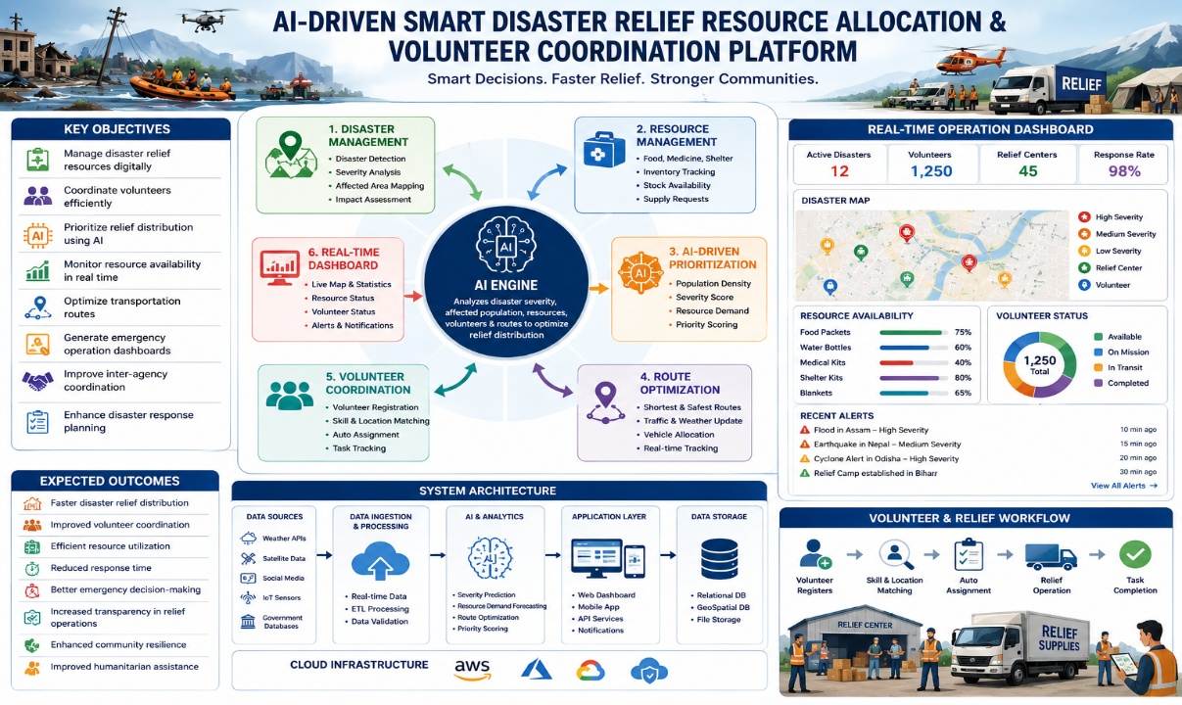
6. Pipeline Diagram & Documentation — 10%
Complete CI/CD Workflow
┌─────────────┐
│ Developer │
└──────┬──────┘
↓
┌─────────────┐
│ GitHub │
└──────┬──────┘
↓
┌─────────────┐
│ GitHub │
│ Actions │
└──────┬──────┘
↓
┌─────────────┐
│ Build │
└──────┬──────┘
↓
┌─────────────┐
│ Unit/API │
│ Tests │
└──────┬──────┘
↓
┌─────────────┐
│ SonarQube │
│ Quality │
└──────┬──────┘
↓
┌─────────────┐
│ Security │
│ Scan/Trivy │
└──────┬──────┘
↓
┌─────────────┐
│ Docker │
│ Build │
└──────┬──────┘
↓
┌─────────────┐
│ Container │
│ Registry │
└──────┬──────┘
↓
┌─────────────┐
│ Staging │
└──────┬──────┘
↓
┌─────────────┐
│ Acceptance │
│ Testing │
└──────┬──────┘
↓
┌─────────────┐
│ Production │
└──────┬──────┘
↓
┌─────────────┐
│ Monitoring │
│ Prometheus │
│ + Grafana │
└──────┬──────┘
↓
Failure?
/ \
YES NO
↓ ↓
Rollback Continue
Expected CI/CD Outcomes
Objective | Expected Outcome
Faster development | Automated build and deployment
Better reliability | Automated testing before deployment
Improved security | Continuous vulnerability scanning
Reduced deployment errors | Standardized Docker environments
Faster recovery | Automated rollback
Better scalability | Cloud/container-based deployment
Better monitoring | Real-time metrics and alerts
Continuous improvement | Quality reports and pipeline feedback
Final Conclusion
The proposed CI/CD pipeline provides a complete automated software delivery process for the AI-driven disaster relief platform. It integrates source control, automated building, testing, code-quality analysis, security scanning, Docker packaging, staging, production deployment, monitoring, and rollback.
This pipeline ensures that new features such as AI-based disaster prioritization, resource allocation, volunteer assignment, GIS route optimization, and emergency dashboards can be delivered rapidly while maintaining reliability, security, and availability. The approach directly addresses all six evaluation criteria and targets the Excellent (4 Marks) level.

